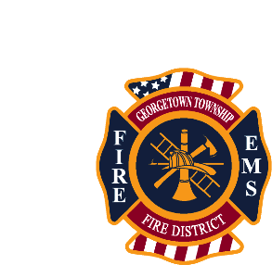
Notice of : Public Sealed bid for sale of equipment.
Equipment For Sale: Truck Bed Toolbox: Weather Guard
$400.00 Minimum Bid Acceptance
Description Of Equipment: Weather Guard 127-05-02 Gloss Aluminum Black Standard Saddle Box.
Bid Information: The Sealed Bidding process will begin on Monday August 14, 2023, at 0800 and will close on Friday August 25th, 2023, at 1700. All Bids must contain the bidders Name, Address, working phone number, email address, as well as the dollar amount the bidder is prepared to pay for the item. All Bids will be opened and reviewed on August 28th at 0900 hrs. The person who offers the highest dollar amount will be awarded the item. Once the winning bid has been selected and you have been contacted you will have 72 hours to pay for and take possession of the item.
In The Event Of A Tie: If more than 1 bidder offers the same amount that happens to be the highest amount offered for the item then all bidders involved with the tie will be contacted. The bidders involved will then have 48 hours to drop off a new sealed bid. At the end of the 48 hours we will open and review the new bids and will contact the highest bidder. They will then have 72 hours to pay for and take possession of the item.

Please feel free to contact our headquarters station with any questions concerning this process @ 812- 948- 0288

